Imam Mohammad Ibn Saud Islamic University
College of Computer and Information Sciences
Computer Science Department

Course Title: | Software Engineering 1
Course Code: | CS1350
Assignment: | Project
Semester: | Second Semester, 2026
Marks: | 30

Train Schedule and Reservation Management System

Course Instructor: | Prof.gufran Ahmad Ansari
Section No.: | 172

Student names | Student ID
(Leader) Mohanad bintaleb | 446001865
Abdulaziz alwayli | 446003688
Abdulrahman aljaber | 446003143

Project Initiation

Project Scope

This project is about a Train Schedule and Reservation Management System. It works as one central platform for train data.
Main idea — keep everything in one place.
The system will help staff handle several things:
- Create train schedules
- Edit or remove schedules
- Register passenger information
- Process ticket bookings
- Check seat availability
Railway data will be organized inside the system. This makes reservation work easier.
Reports will also be generated.
These reports help admins check:
- Booking trends
- Seat occupancy
- Total revenue
Some things are not included in this system.
Examples:
- No external payment gateway
- No direct passenger self-service booking
All actions in the system are done by authorized staff only.

Project Objectives

The system has several goals.
Main objectives:
- Manage train schedules in one central system
- Improve the accuracy of passenger reservation records
- Track seat availability automatically during booking or cancellation
- Make passenger information easy to manage
- Store passenger booking history
- Give admins reports to help with decisions
Simple goal = better organization of railway data.
Target Audience
Two main groups will use this system.
- Railway administrators
- Railway staff members
Each group has a different role.
Administrators —
- Manage train schedules
- Monitor how the system performs
- Generate reports
Staff members —
- Register passengers
- Handle ticket reservations
- Manage bookings and cancellations
Passengers themselves do not access the system directly.

Project Vision

The goal is to build a secure and reliable platform.
The system should make railway management easier.
It will help staff organize train schedules and reservations.
Manual mistakes should become less common.
Important railway data will be easy to access.
The interface should be simple and clear.
Future expansion is also possible.
Examples:
- Automated reporting tools
- Extended digital reservation services
Idea in short = organized railway management in one system.

Product Backlog Creation

Functional requirments

User Story ID | User Story Title | Brief Description | Additional Information | Priority
S1 | modify train schedules | As an administrator I want to be able to update delete and create train shedules so that train schedules are up to date |  | 1-high
S2 | define depart/routes/arrive times | As an adminstrator I want to be able to define arrival , departure and routing times so that the times are accurate for passengers |  | 1-high
S3 | seat capacity and ticket pricing | As an adminstrator I want to be able to specify the seats capacity and ticket pricing to avoid overcrowding and manage rush hours |  | 2-medium
S4 | Historical records | As an adminstrator I want to be able to maintain historical shedule records to analyze efficiency |  | 3-low
S5 | Passenger profiles | As a staff member I want to be able to register and manage passenger profiles so that we have required information for future use |  | 1-high
S6 | ID and contact details | As a staff member I want to be able to store identification and contact details so that we are able to contact passengers in emergency cases |  | 3-low
S7 | Booking history | As a staff member I want to be able to Maintain booking history for each passenger so that we can keep record of all previous passengers |  | 3-low
S8 | Process ticket reservations | As a a staff member I want to be able to process a ticket reservation so that passengers reservation can be completed |  | 1-high
S9 | seat availability | As a staff member, I want the system to check seat availability before confirming a booking so that double bookings are prevented. |  | 1-high
S10 | Automated remaining seats capacity | As a staff member, I want the system to automatically update remaining seat capacity so that seat data stays accurate. |  | 2-medium
S11 | Ticket cancellation and seat reallocation | As a staff member I want to be able to cancel a reservation and reallocate passengers to new seats in case a passenger wants to cancel or change seats |  | 2-medium
S12 | Booking confirmation | As a staff member, I want the system to generate a booking confirmation so that passengers have proof of reservation. |  | 2-medium
S13 | Display summary statistics | As an admin I want to be able to view summary statistics such as total trains , bookings , revenue so that I can analyze effeciency and work rate |  | 3-low
S14 | seat occupancy rate | As an adminstrator I want to be able to monitor seat occupancy rates so that I can analyze most requested seats |  | 3-low
S15 | Reservation trends | As an adminstrator I want to be able to track reservation trends so that I understand what passengers prefer |  | 3-low
S16 | generate daily/weekly/monthly reports | As an admin I want to be able to generate daily/weekly/monthly booking reports so that the most busy times are known |  | 3-low
S17 | produce revenue reports | As an admin I want to be able to generate revenue analysis reports so that we are able to track how well the financial state is |  | 3-low
S18 | analyze train utilization | As an admin I want to be able to analyze train utilization so that we can shedule trains more efficiently |  | 3-low
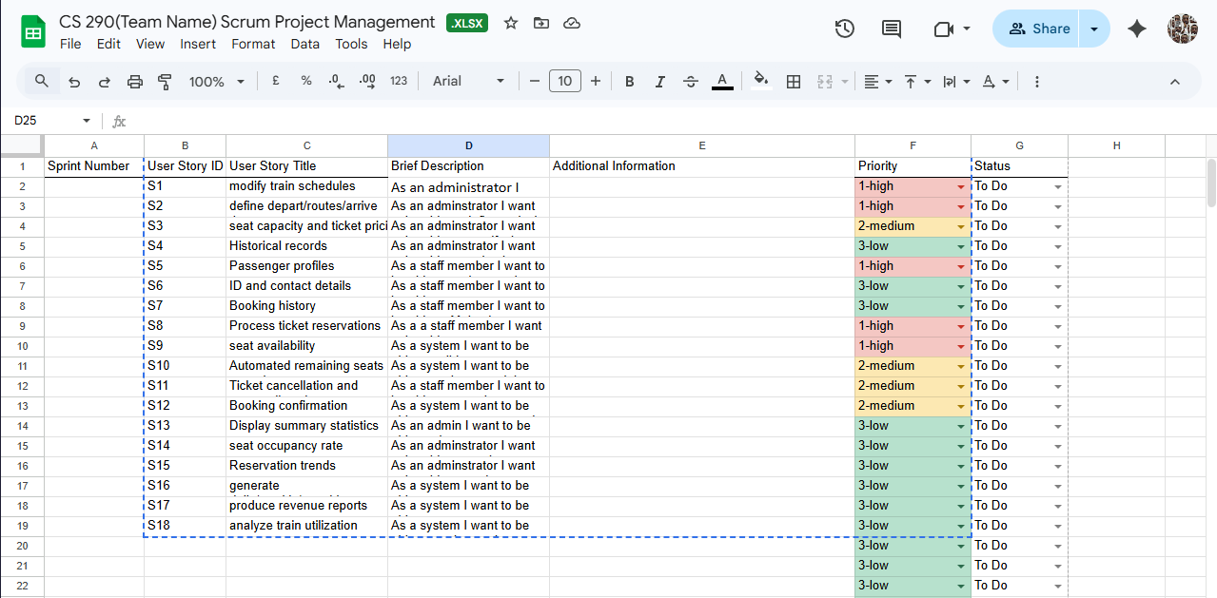

Non-Functional Requirements
Platform Requirements
- Cloud-based system
- Web and mobile support
- Real-time scalability
Security Requirements
- Role-based access control
- Authentication and authorization
- Data validation
- Backup and recovery

Sprint Planning
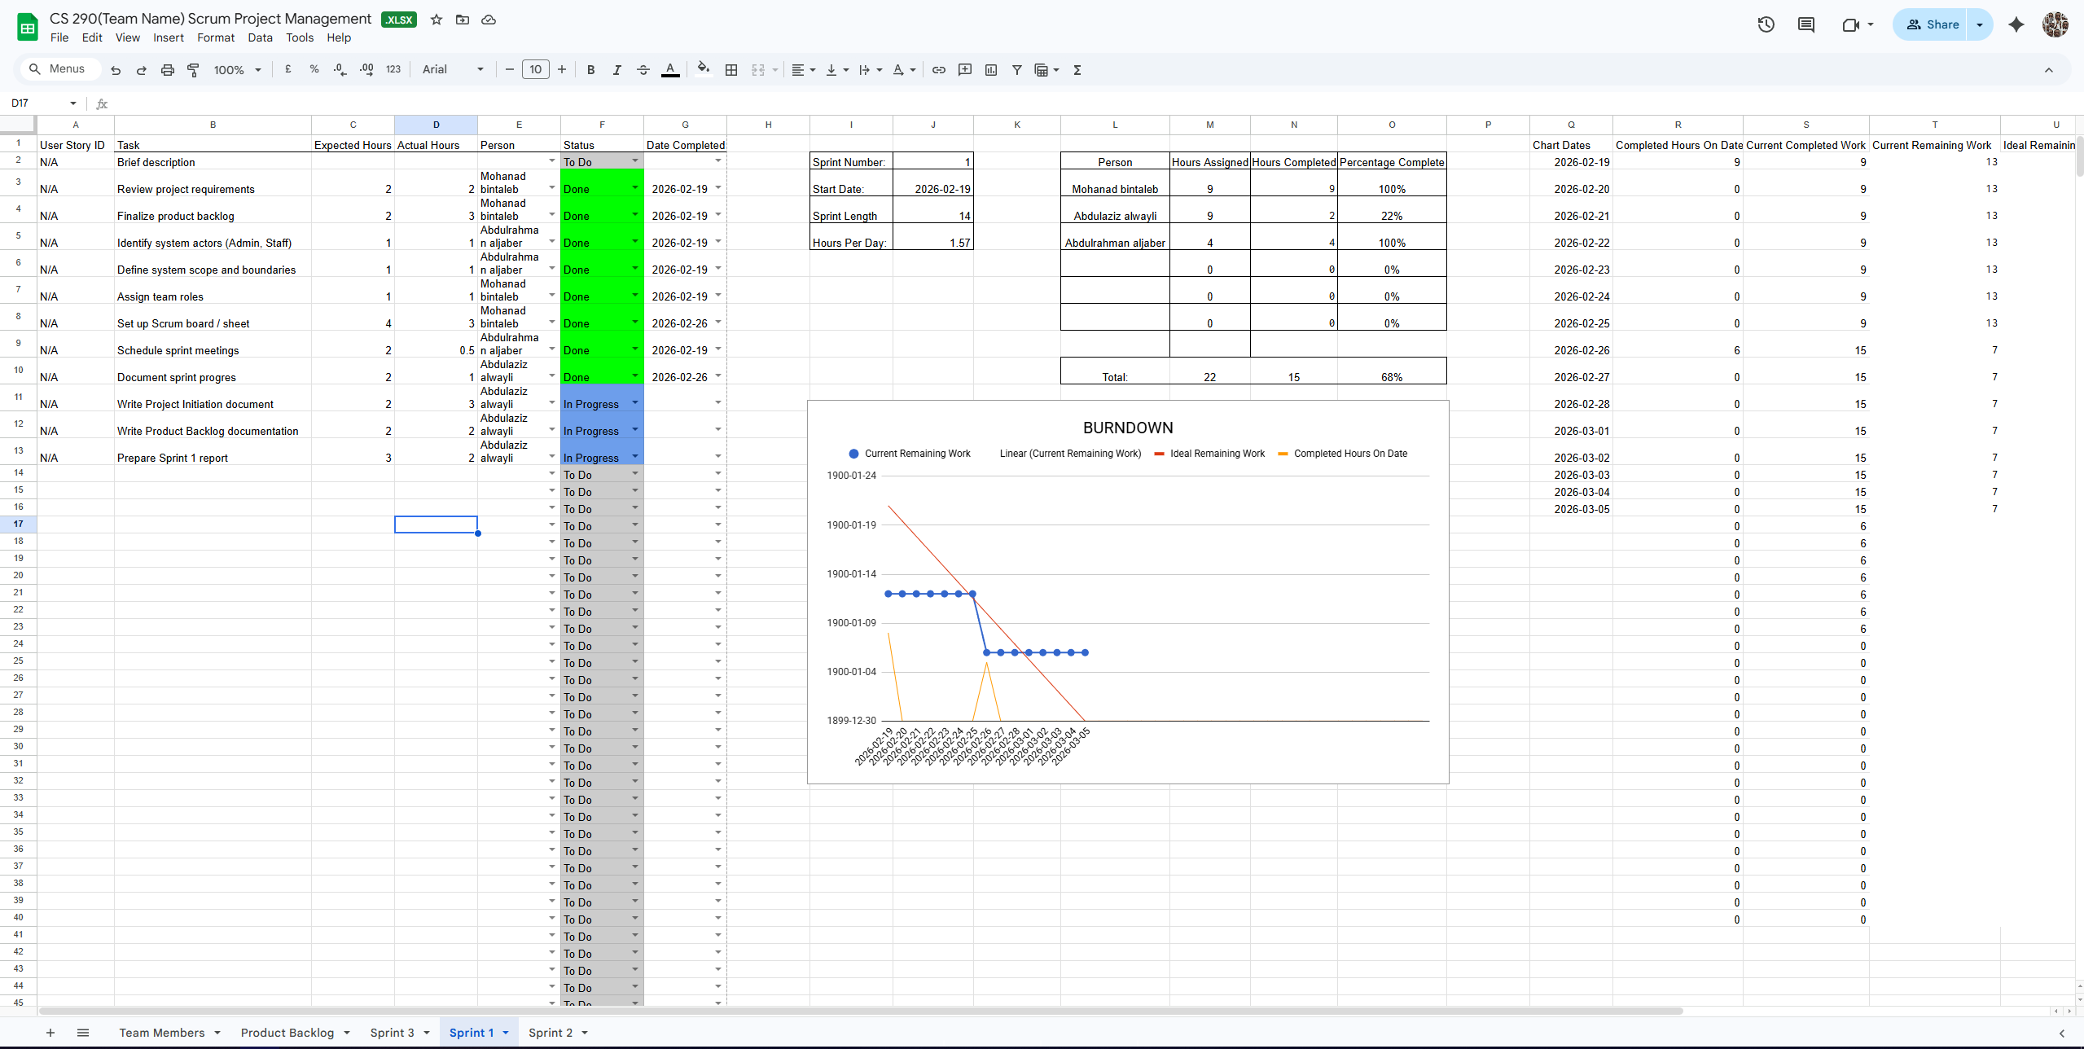
User story ID | Brief description | Expected Hours | Actual Hours | Person
N/A | Review project requirements | 2 | 2 | Mohanad bintaleb | Done | 2026-02-19
N/A | Finalize product backlog | 2 | 3 | Mohanad bintaleb | Done | 2026-02-19
N/A | Identify system actors (Admin, Staff) | 1 | 1 | Abdulrahman aljaber | Done | 2026-02-19
N/A | Define system scope and boundaries | 1 | 1 | Abdulrahman aljaber | Done | 2026-02-19
N/A | Assign team roles | 1 | 1 | Mohanad bintaleb | Done | 2026-02-19
N/A | Set up Scrum board / sheet | 4 | 3 | Mohanad bintaleb | Done | 2026-02-26
N/A | Schedule sprint meetings | 2 | 0.5 | Abdulrahman aljaber | Done | 2026-02-19
N/A | Document sprint progres | 2 | 1 | Abdulaziz alwayli | Done | 2026-02-26
N/A | Write Project Initiation document | 2 | 3 | Abdulaziz alwayli | In Progress
N/A | Write Product Backlog documentation | 2 | 2 | Abdulaziz alwayli | In Progress
N/A | Prepare Sprint 1 report | 3 | 2 | Abdulaziz alwayli | In Progress

Group meeting
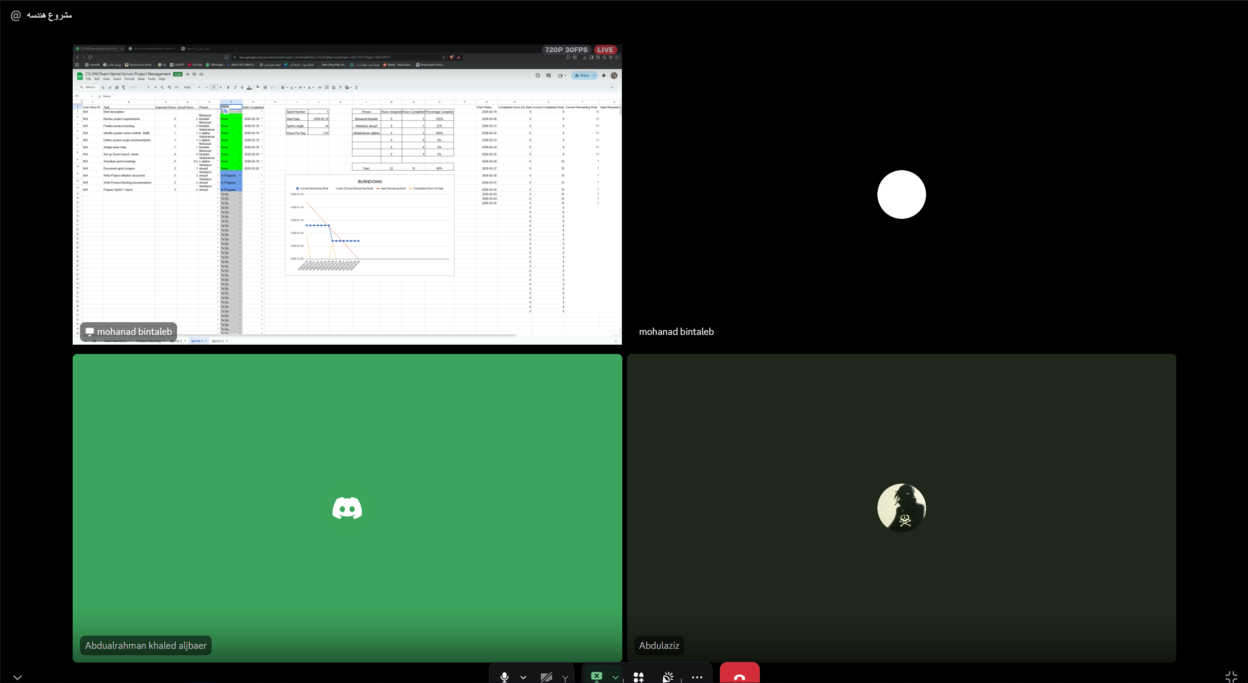
The first group meeting has been held in 19/2/2026 during which the project overall path has been planned and the tasks have been distributed among the team members other meeting has been held to inquire on some roadblocks the team has faced .

